ERD Tables Assignments

Faryal :

* Brew Master
* Taproom Manager
* Sales Manager
* Bartender
* Brewer

John

* 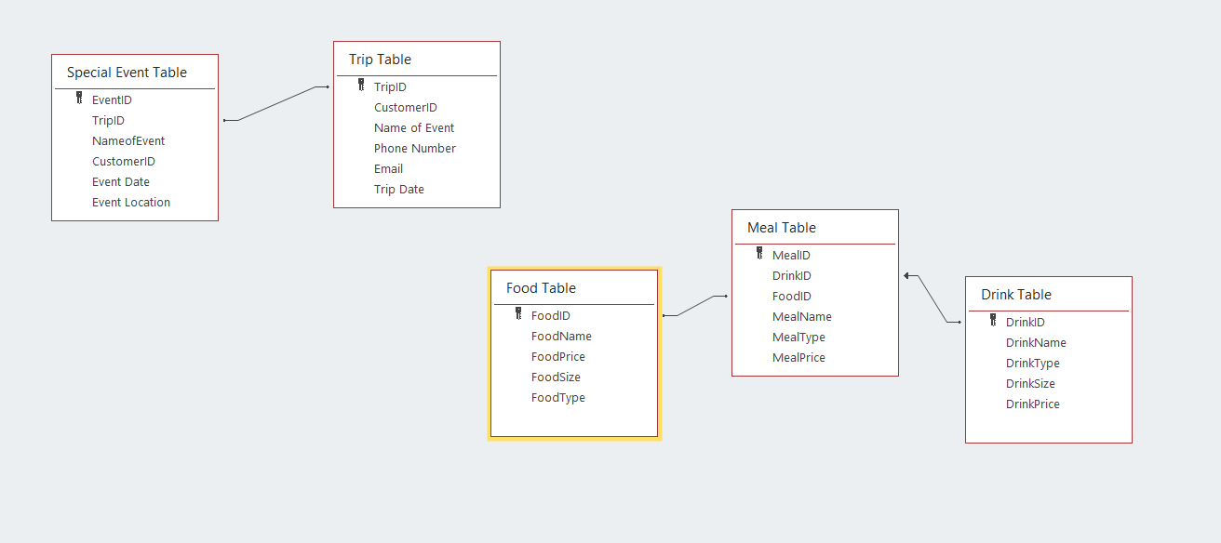

Chantera:

* Coupon

|  |
| --- |
| ID |
| Product_category_ID (optional) |
| Issue Date |
| Expiration Date |
| Discount_value |
| Discount_unit |
| Coupon_code |
| minimum_order_value |
| Max_discount_amount |
| Description |

* Bundle/gift sets

Gift_set/bundles

|  |
| --- |
| GID |
| product_bundle_name |
| Is_active (allows for bundles to be added and deleted) |
| Discount_value |
| Original Value |

Product bundle table to connect to product table

|  |
| --- |
| ProductID |
| Quantity |
| GID |

* Tokens (sets of 3 or 4)

Tokens Purchased

|  |
| --- |
| ID |
| Customer_ID |
| Purchase_ID (Receipt) |
| Total_#_of_Tokens_Purchased (with a rule that it has to be sets of 3 or 4) |
| Total Price |

Customer Available tokens

|  |
| --- |
| ID |
| Customer_ID |
| Token_Quantity |

Used Tokens

|  |
| --- |
| ID |
| Customer_ID |
| Purchase_ID (Receipt) |
| Product_ID (RULE: MUST BE CORE BIER) |
| Product_Description |

Sem :

* Glassware

|  |
| --- |
| Glassware |
| order_num |
| invoice_num |
| glass_size |
| glass_price |
| glass_desc |

* T-shirts

|  |
| --- |
| T-Shirts |
| order_num |
| invoice_num |
| tshirt_num |
| tshirt_size |
| tshirt_color |
| tshirt_design |
| tshirt_price |

* Hats

|  |
| --- |
| Hats |
| order_num |
| invoice_num |
| hat_size |
| hat_color |
| hat_design |
| hat_price |

* Bottles

|  |
| --- |
| Bottles |
| order_num |
| invoice_num |
| bottle_sizeOZ |
| bottle_label |
| bottle_price |

Pratik:

* Core bier type

|  |
| --- |
| ID |
| Bier_Name |
| Bier_Type |
| Alcohol_Content |
| Bier_quantity |

* Specialty bier type

|  |
| --- |
| ID |
| Bier_Name |
| Bier_Type |
| Alcohol_Content |
| Bier_quantity |

* Location

|  |
| --- |
| ID |
| brewery_name |
| brewery_address |

State Table:

|  |
| --- |
| ID |
| brewery_state |

Country table:

|  |
| --- |
| ID |
| brewery_country |

City table:

|  |
| --- |
| ID |
| brewery_city |

Zip Code table:

|  |
| --- |
| ID_c |
| brewery_zip_code |

Faryal :

* Brew Master

|  |
| --- |
| ID |
| First_Name |
| Middle_Name |
| SSN |
| DOB |
| Address |
| Salary |

* Taproom Manager

|  |
| --- |
| ID |
| First_Name |
| Middle_Name |
| SSN |
| DOB |
| Address |
| Salary |

* Sales Manager

|  |
| --- |
| ID |
| First_Name |
| Middle_Name |
| SSN |
| DOB |
| Address |
| Salary |

* Bartender

|  |
| --- |
| ID |
| First_Name |
| Middle_Name |
| SSN |
| DOB |
| Address |
| Salary |

* Brewer

|  |
| --- |
| ID |
| First_Name |
| Middle_Name |
| SSN |
| DOB |
| Address |
| Salary |

Adekunle:

* Bier size- pint
* Bier size- 32 ounce
* Bier size- 62 ounce
* Bier size- gallon

